Ronnie Rozo

David Shabo

Final Report

Introduction

For this project our initial plan was to make a mini security system, it involved a toy pellet shooter, that was made up of gears that pulls back a spring to its maximum tension and then releases the spring, and converts the kinetic energy from the spring to the plastic ballot, that repels it forward. The toy pellet shooter would point to where an object would be passing a motion sensor and the shooter would then fire a pellet. This plan then changed to using a laser pointer set atop a servo motor in conjunction with two distance sensors.

    Based on the information about the motion sensor, it was not accurate for it to detect an object in front of it and then turn to the correct angle. Had ideas of putting a funnel in front of the motion sensor, to give it tunnel vision, and then have the servo turn in a repeated loop until it detected something in front of it. But, there were still some problems, if the object stops while the motion sensor is in its line of sight. The professor gave us a better idea that instead of a motion sensor, use a distance sensor instead. Keep two distance sensors on the x axis, and the servo motor in the middle of it. After doing more research on the distance sensors, we discovered that the ranges of the sensors were from 10cm to 80cm. The room that we were going to use was only going to be about six feet. So there was no point in having two sensors. Instead, one sensor was on the x axis, while the other sensor was on the y axis, that way the motor can be moved to any position on the y axis. Another problem was that the motor was let in the middle of the room. By having it in that position, the graph will have two perfect triangles, which would make the programming more complicated. So instead the motor was moved all the way to the corner, so that the graph is only one perfect triangle. As seen in the picture below.

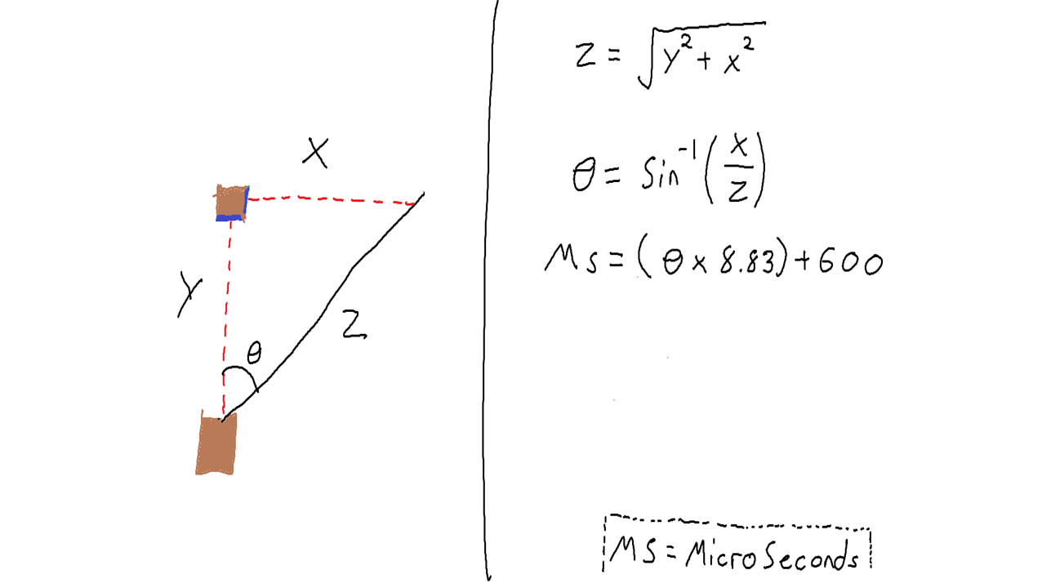

In this picture we translated the problem we have into the Pythagorean Theorem, above X and Y correlate with the distance sensors. The box with the angle above it is the servo motor with the laser attached to it, and Z is an unknown value we need to figure out. We settled on the Pythagorean Theorem through research and found that the angle could be used to find the correct microseconds the servo motor would need to turn. We would first need to program the theorem to get the correct values for Z and the angle, and we would then use the equation above MS= (angle * 8.83) + 600.

**Constructing and testing**

With our plan in order we looked into how best to connect the components we have with the msp430 given to us, and we also looked into code that will help get us to test the servo motor we have. We first had to figure out how much voltage the components will need, through web browsing, we found that the components needed more than the 3.3 volts the msp430 could offer.  The msp430 does happen to provide 5.5v, but only through use of tp1 and tp3. So we soldered pins onto the top holes for easier use, so getting the required voltage to our components was no longer the issue. It did not take long after until we ran into a problem, we started testing the distance sensors. We used the midterm program that was used previously to test other sensors, and after setting up everything we were getting random to no change from our distance sensor values. We first questioned the code being wrong so we looked for help from the professor; upon meeting with the professor he was able to figure out that the pull-up resistors inside the microcontroller were affecting the results.  After that we simply needed to turn off the pull-up resistors, and after we were able to attain accurate readings from our sensors.

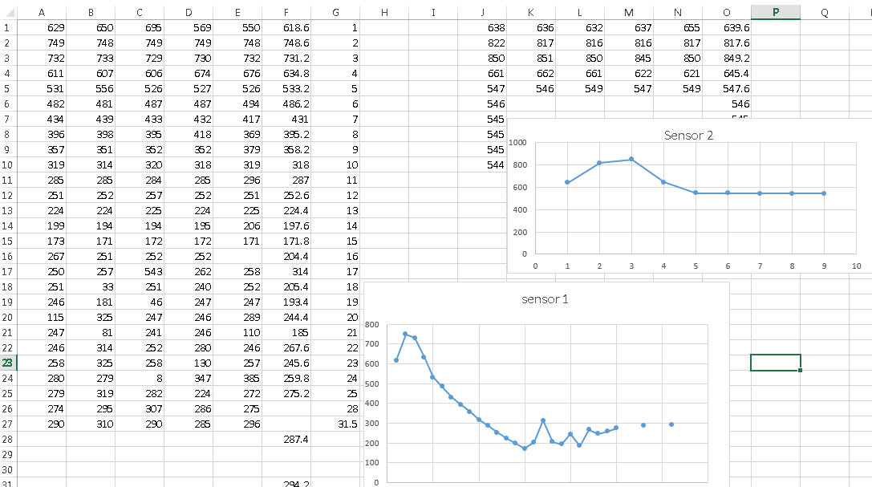

The graph above is of past readings we got, we found that disassembling and reassembling the components would give us different results. So we included it to show how varied and sensitive the distance could potentially be. Take note that in this we included the values past 15 inches for sensor 1 and we showed that results did not change after a certain distance for sensor 2. In our other graph we did not measure past 15 inches due to how the results change thereafter.

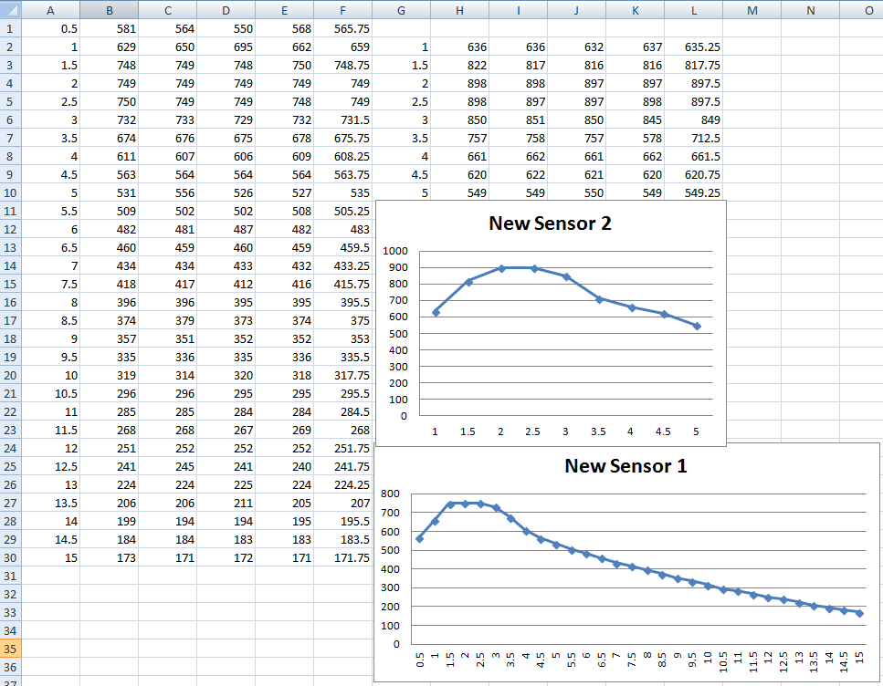

In the graph above is the result we ended up with after testing the distance sensors every half an inch, the max distance for sensor 1 was kept at 15 inches due to sporadic and random results thereafter. And after 5 inches in sensor 2 we found little to no change in the readings, these were the final readings we had when we presented the final project. The first graph shows the calculations we got after going past 15 inches, which help support our decision of keeping it at 15 inches. Programming this was the only thing left before making a wooden construction, we blended together code we found that moved the servo motor with the  midterm code used to test the distance sensors.  We started by setting conditions of distance sensor values up to where we felt the results were consistent.  If results matched they would be given an integer value correlating it with inches from the graph.  By doing this, the code now has a table for both the x and y axis.  After these statements, the equations for the Pythagorean Theorem were included as well as the equation for microseconds.  The servo did not initially turn to the places we wanted as accurately, so we then tweaked the values for the microseconds equation to make up for that. Construction began by making an x and y axis related to their max value in inches, the y value had a line shaped hole so we could move the servo along the y axis. After this the sensors were glued onto a block facing their intended directions, and lastly were wiring it all up to get the final values for distance sensors.

Conclusion

To conclude, as a group there was no predictions on how this project would end up with how little experience we had with the components and microcontroller. Though there were some problems had through completing this, solutions to them were not far found thanks to the teaching assistants and professor.  In the last day we felt we had a finished project, and after presentation others did hopefully as well. After completion of this project we leave with a greater understanding of how some electronic projects are handled and learning to see a plan on till the end.